2012 AP UNITED STATES HISTORY FREE-RESPONSE QUESTIONS
UNITED STATES HISTORY
Directions: The following question requires you to construct a coherent essay that integrates your interpretation of Documents A-G and your knowledge of the period referred to in the question. High scores will be earned only by essays that both cite key pieces of evidence from the documents and draw on outside knowledge of the period
- “From 1933-1941, America was an isolationist country and did not want to be entangled in foreign affairs.” Address the validity of this statement. To what extent is this statement true? Be sure to include political, economic, and social changes during this time.
Document A
Source: Carrey Orr, “The Only Way We Can Save Her,” 1939
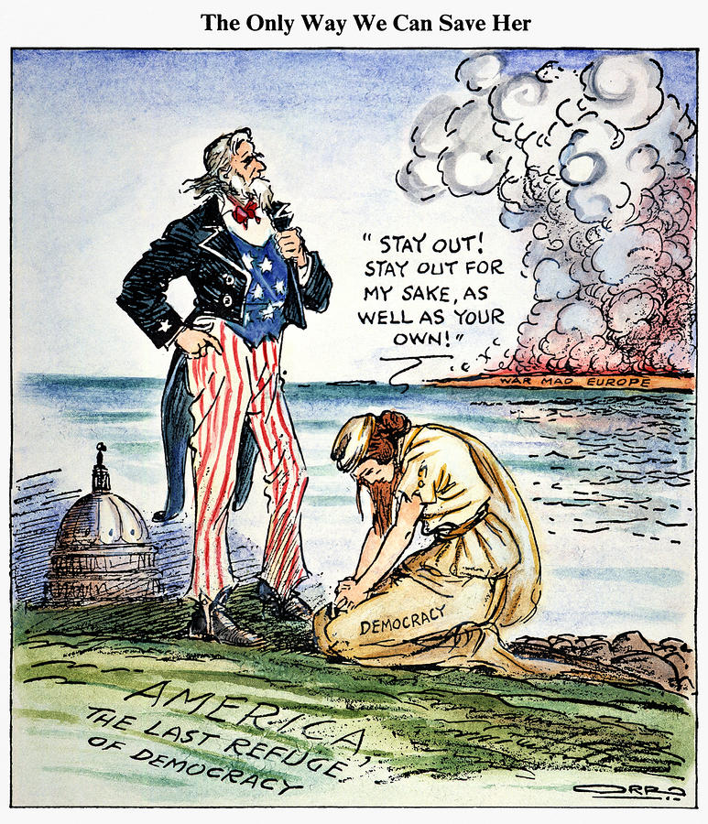

Document B
Source: Max Gordon, Committee to Defend America by Aiding the Allies, 1941
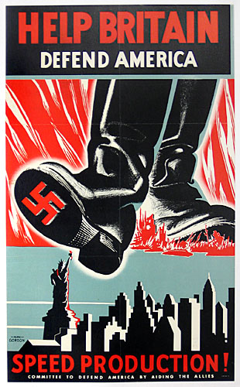

Document C
Source: Neutrality Act of 1935
“Resolved by the Senate and House of Representatives of the United States of America in Congress assembled, That upon the outbreak or during the progress of war between, or among, two or more foreign states, the President shall proclaim such fact, and it shall thereafter be unlawful to export arms, ammunition, or implements of war from any place in the United States, or possessions of the United States, to any port of such belligerent states, or to any neutral port for transshipment to, or for the use of, a belligerent country…The President, by proclamation, shall definitely enumerate the arms, ammunition, or implements of war, the export of which is prohibited by this Act… The President may, from time to time, by proclamation, extend such embargo upon the export of arms, ammunition, or implements of war to other states as and when they may become involved in such war.”

Document D
Source: Hadley Cantril, ed. Public Opinion, 1935-1946

Document E
Source: Franklin Delano Roosevelt, “Quarantine Speech,” Delivered at Miller Center, October 5, 1937
“There is a solidarity and interdependence about the modern world, both technically and morally, which makes it impossible for any nation completely to isolate itself from economic and political upheavals in the rest of the world, especially when such upheavals appear to be spreading and not declining. There can be no stability or peace either within nations or between nations except under laws and moral standards adhered to by all International anarchy destroys every foundation for peace. It jeopardizes either the immediate or the future security of every nation, large or small. It is, therefore, a matter of vital interest and concern to the people of the United States that the sanctity of international treaties and the maintenance of international morality be restored. The overwhelming majority of the peoples and nations of the world today want to live in peace. They seek the removal of barriers against trade. They want to exert themselves in industry, in agriculture and in business, that they may increase their wealth through the production of wealth-producing goods rather than striving to produce military planes and bombs and machine guns and cannon for the destruction of human lives and useful property.”

Document F
Source: Massachusetts Women's Political Club protest against the Lend-Lease bill. February 26, 1941
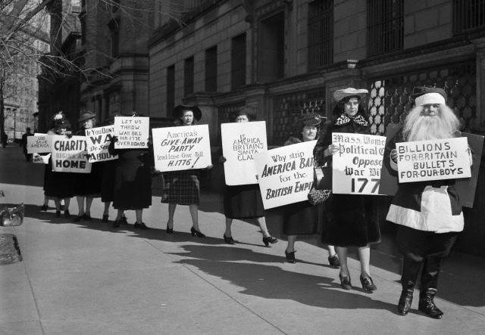

Document G
Source: Arthur H. Vandenberg, U. S. Senator from Michigan, Delivered at St. Paul, Minn., February 10, 1940
“This distraught world is riddled with bitter, horrifying wars which wrench our hearts, ravish our ideals, and consume us with hatreds for sanguinary despots who extinguish the very lamps of civilization. Deep and impulsive emotions might easily drive us once more to these battle lines 3,000 miles away. But we must ever take counsel of reality. Reality says we cannot hope to control the destiny of power politics in the Old World. Reality says we must avoid entangling contracts…We have no business in any kind of partnership with such an outlaw. Reality tells us that our own stupendous obligation to democracy is to keep its torch alight in this New World… Reality demands that we must avoid these wars by every effort consistent with national security and honor. We can stay out if we will—and stay out we must. When we are attacked, we shall respond with every man and every dollar beneath the flag. Until we are attacked we shall hold our peace. America must be our exclusive, dominating dedication. America must be our passion. And none but devoted, single-purpose Americans must be put on guard…Our battles, my fellow countrymen, are here at home…”

